**CIS 422**

**User Documentation for YACC**

**CIS 422**

Team Number 6

499ms

Zachary Bower, Chase Craig, Refael Yehuda, Noah Palmer, Benjamin Yin

User Documentation

Version 1.0 Date: (02/04/2019)

Table of Contents

**1. Software Installation and Setup** **3**

1.1. Binary Install 3

1.2. Source Install 3

1.2.1. Installation Script 3

1.2.2. Manual Installation 3

**2. User Use** **5**

2.1. Viewing the Month 5

2.2. Viewing the Events of the Day 6

2.3. Adding an Event 7

2.4. Selecting an Event 8

2.5. Editing an Event 9

2.6. Deleting an Event 10

# 1. Software Installation and Setup

The most current version of our code is available <https://github.com/pork3/team499ms>.

Prior to installation, the user should ensure the following requirements are met:

1. Java Runtime Environment 11
2. Git (optional) as github distributes archived source, but highly recommended
3. GNU/Linux Operating System

## 1.1. Binary Install

A binary package is available through github, either visit <https://github.com/pork3/team499ms> and download the zip file, extract and run the jar file, or use git

|  |
| --- |
| $ git clone https://github.com/pork3/team499ms.git  $ cd team499ms $ java -jar YACC.jar |

## 1.2. Source Install

Source installation is offered through two means, one is an install script available online. Just download the script, set proper permission, then enjoy.

### 1.2.1. Installation Script

1. Download installation script

|  |
| --- |
| $ wget ix.cs.uoregon.edu/~zbower/shell/downloadYACC.sh  $ ./downloadYACC.sh |

1. There is now a YACC.jar file located in the following directory:

|  |
| --- |
| $ ../team499ms/Code/src/ |

1. You can move the .jar file to any location you want, and it can be run with the command

|  |
| --- |
| $ java -jar YACC.jar |

### 1.2.2. Manual Installation

1. First download both YACC and JSON dependency

|  |
| --- |
| $ git clone https://github.com/pork3/team499ms.git $ git clone https://github.com/stleary/JSON-java |

1. Compile the JSON library

|  |
| --- |
| $ mkdir org $ mkdir /org/json $ javac JSON-java/*.java $ mv JSON-java/*.class JSON-java/org/json |

3. Copy JSON library to proper location

|  |
| --- |
| $ cp -r JSON-java/org /team499ms/Code/src |

4. Compile YACC

|  |
| --- |
| $ cd team499ms/Code/src $ javac edu/uoregon/cs/calendar499/*.java |

5. Create Manifest.mf file

|  |
| --- |
| $ echo "Manifest-Version: 1.0" >> MANIFEST.MF $ echo "Class-Path: ." >> MANIFEST.MF $ echo "Main-Class: edu.uoregon.cs.calendar499.Main" >> MANIFEST.MF $ echo "Created-By: SICKboy" >> MANIFEST.MF $ mkdir META-INF $ mv MANIFEST.MF META-INF |

6. Create Jar

|  |
| --- |
| $ jar cvfM YACC.jar META-INF/MANIFEST.MF edu/uoregon/cs/calendar499/*.class edu/uoregon/cs/calendar499/*.png org/json/*.class |

7. There is now a YACC.jar file located in the following directory:

|  |
| --- |
| $ ../team499ms/Code/src/ |

8. You can move the .jar file to any location you want, and it can be run with the command

|  |
| --- |
| $ java -jar YACC.jar |

# 

# 2. User Use

## 2.1. Viewing the Month

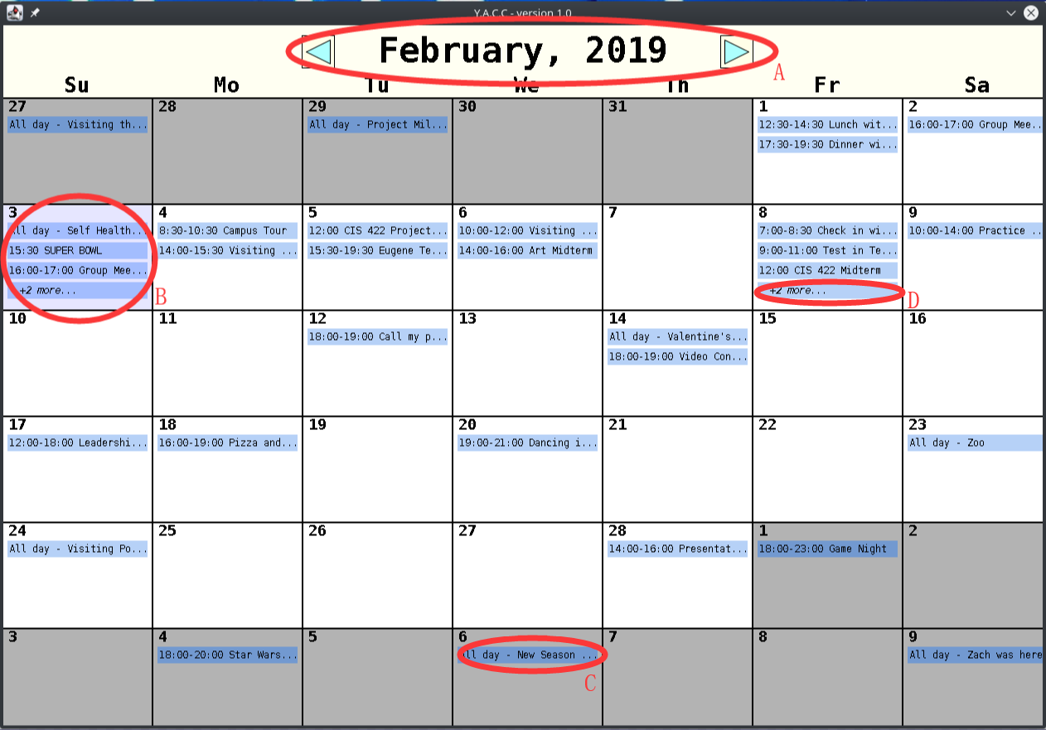

Screen Components:

1. Display the current month and year. User able to switch month by clicking left button or right button.
2. Blue box represents the current date.
3. Next/Previous month days are grey and when clicked will shift to that month.
4. Shows “+X more ..” for more than 4 events in one day.

Keyboard Features:

* PGUP - Will shift the month view to the previous month.
* PGDN - Will shift the month view to the next month.
* HOME - Will shift the month view to the current month.

## 2.2. Viewing the Events of the Day

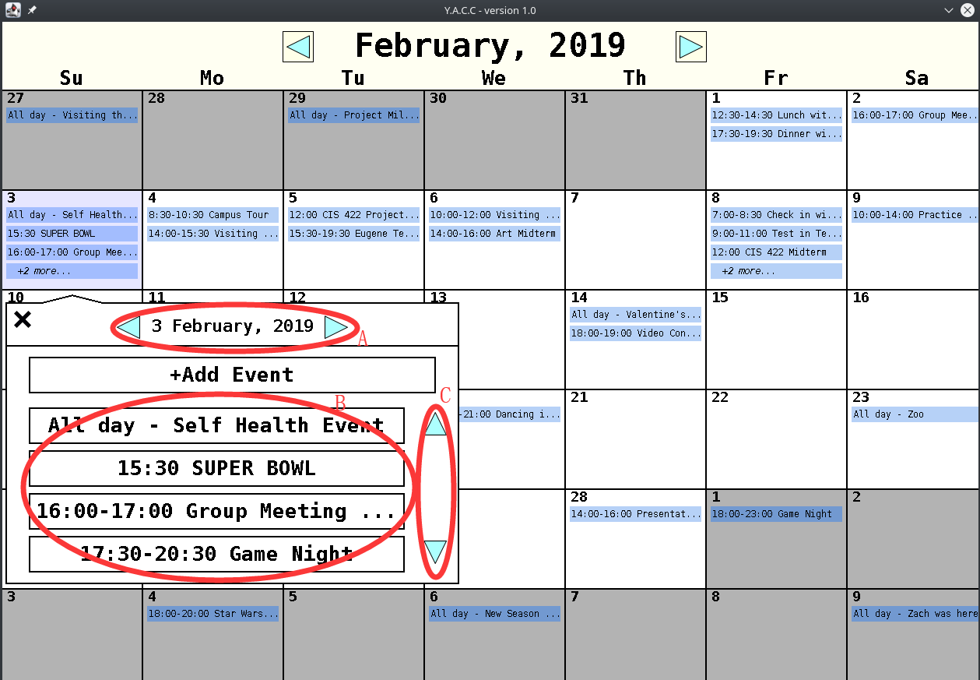

Screen Components:

1. User able to change the date by click left and right button.
2. Display the events of selected date.
3. Use up and down button to check more events on that day.

Keyboard Features:

* LEFTARROW - Will move the day view to the previous day.
* RIGHTARROW - Will move the day view to the next day.
* ESC - Will exit the day view.

## 2.3. Adding an Event

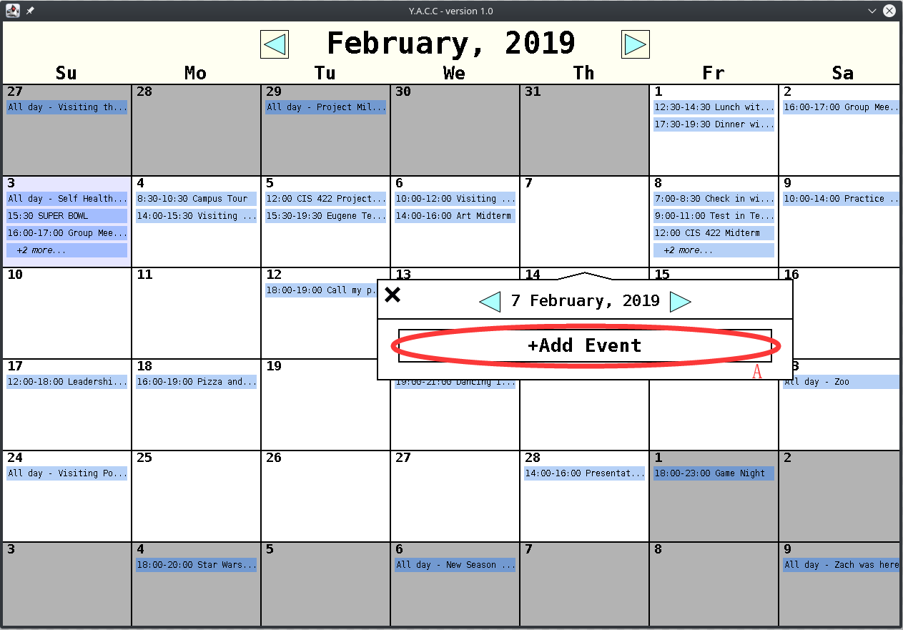

Screen Components:

1. Click “+Add Event” button to add event, for editing the details of the event go to page Editing an Event.

## 2.4. Selecting an Event

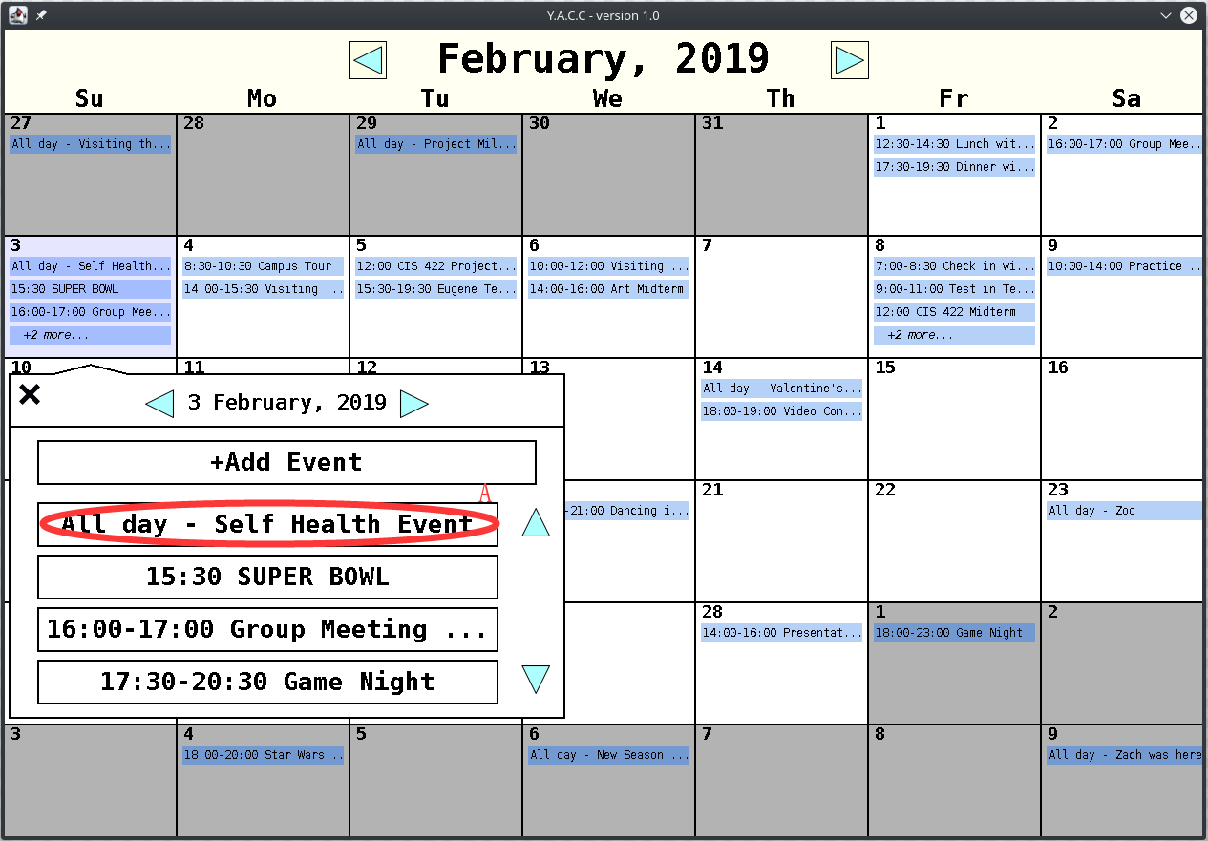Screen Components:

1. Click the event to select the event. User can either edit or delete the event.

## 2.5. Editing an Event

Screen Components:

1. Edit event name.
2. Edit event time duration. User can click the button to make it 24 hours duration.
3. Edit description of the event.
4. After edit it, User need to click the button to save the edited details.

Keyboard Features:

* TAB - Will cycle through the editable features of an event.
* ESC - Will exit the event editor.
* LEFTARROW - Moves event to previous day.
* RIGHTARROW - Moves event to next day.

Types of Events

* All Day Events - Can Click “All Day Event?” button to set as all day event.
* Single Time Events - Can type same time for both start and end for single time event.
* Time Span Events - Can type different times for stand and for time span event.

## 2.6. Deleting an Event

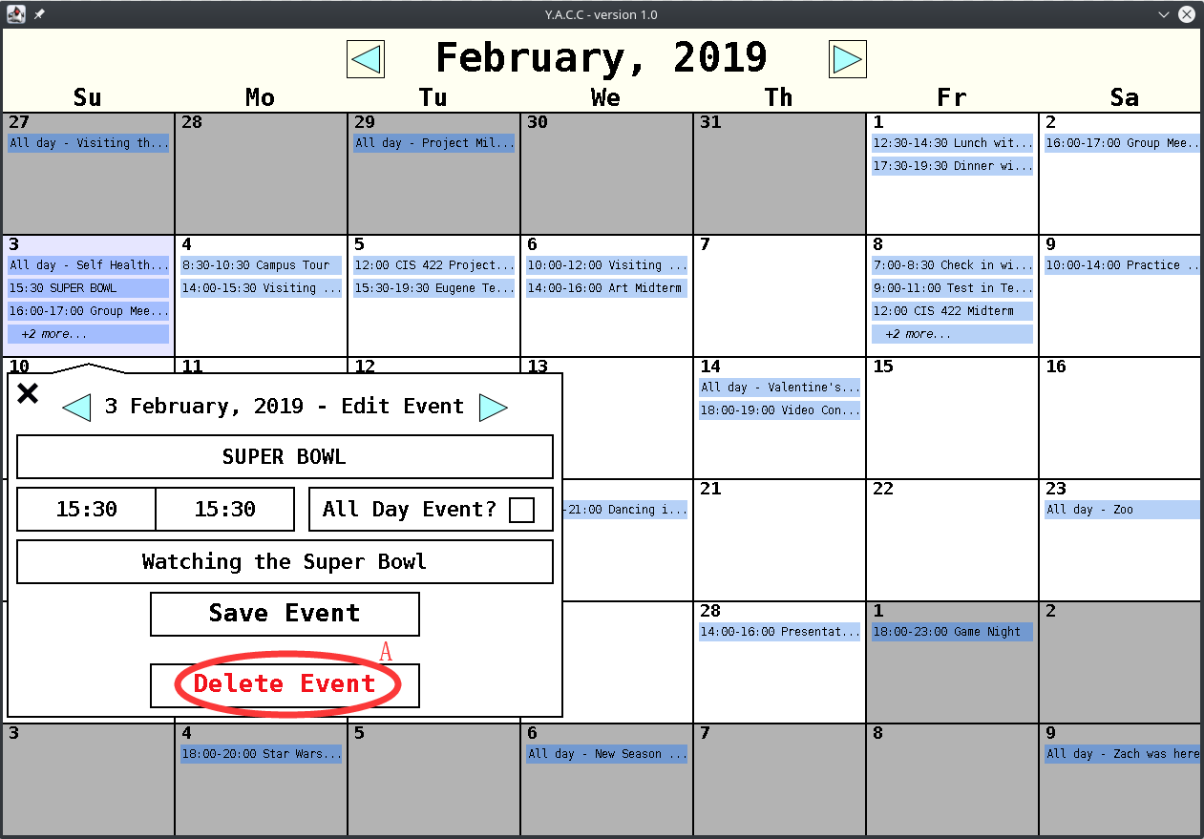

Screen Components:

1. Click button to delete the selected event.